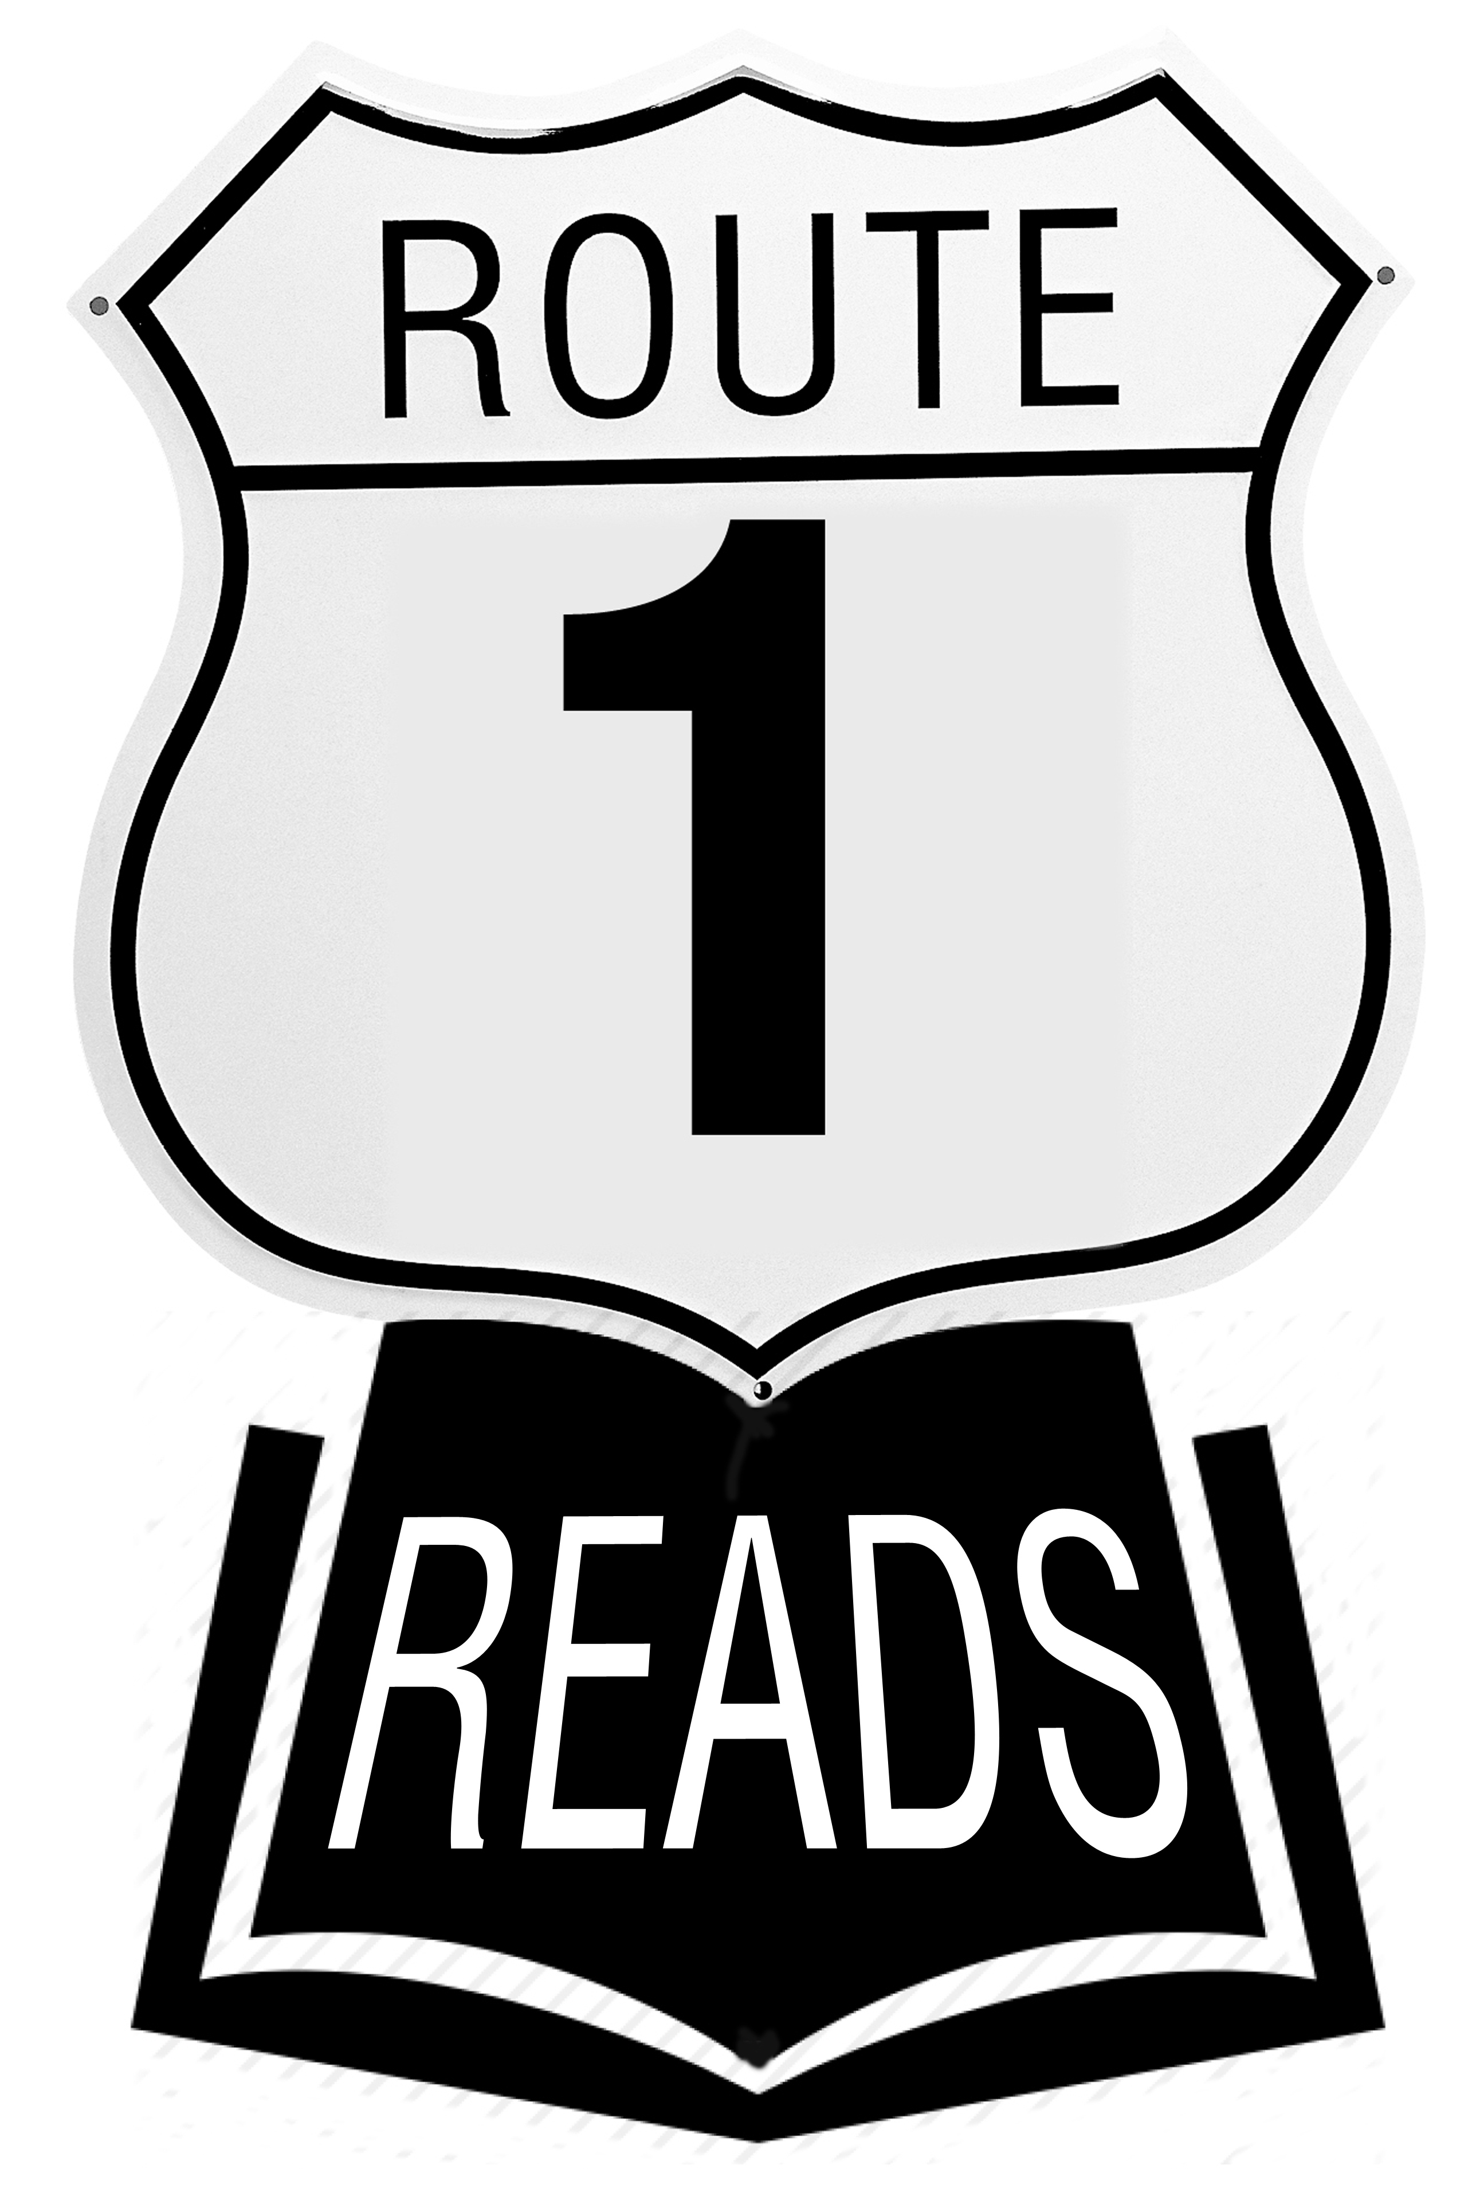
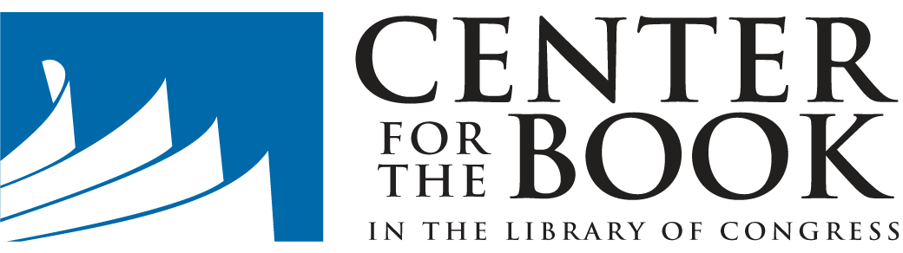

FOR IMMEDIATE RELEASE
Contact: Sarah Lawson, Assistant Director
Virginia Center for the Book
Phone: 434-982-2983
Email: sdlawson@virginia.edu

East Coast Centers for the Book Announce Selections for 2018 Route One Reads

May 8, 2018—For the fourth consecutive year, 16 Centers for the Book along the length of the East Coast will participate in the Route One Reads initiative, a roadtrip-inspired reading list that explores various genres through the network of state Center for the Book affiliates located along Route 1.

Through Route One Reads, readers can travel across 15 states and the District of Columbia without taking a single footstep, or load selected books into the car for a literary road trip. In 2018, the theme of the reading will be romance novels. Virginia Center for the Book director Jane Kulow says, “Whether readers are at home or on the road this summer, we hope that this list of must-read romances will keep them turning pages until Labor Day.” The full list of featured books is listed here, in geographical order from North to South:
MAINE— The Remedy for Love by Bill Roorbach
NEW HAMPSHIRE— Love Free or Die: Twenty-three Tales of Love from the Granite State by V/A
MASSACHUSETTS— Some Kind of Hero by Suzanne Brockmann
RHODE ISLAND—Treading Water by Marie Force
CONNECTICUT—The Thunder Beneath Us by Nicole Blades
NEW YORK—Sex and the City by Candace Bushnell
PENNSYLVANIA—Remember When by Lindsay Detwiler
NEW JERSEY—Need to Know by Fern Michaels
DELAWARE—Reclaim My Heart by Donna Fasano
MARYLAND—Come Sundown by Nora Roberts
WASHINGTON, D.C.—Big Girls Don’t Cry by Connie Briscoe
VIRGINIA—Love On My Mind by Tracey Livesay
NORTH CAROLINA—Garden Spells by Sarah Addison Allen
SOUTH CAROLINA—The Beach House by Mary Alice Monroe
GEORGIA—Mr. Right-Swipe by Ricki Schultz
FLORIDA—Stiltsville by Susanna Daniel
To take part, just pick up one of these books at a local bookstore or library and start reading. The full reading list is available, with details about each title and an interactive map, at Route1Reads.org.
# # #

About Route One Reads: Connecting the 2,369 miles of U.S. Route 1 from Ft. Kent, Maine, to Key West, Florida, the Route One Reads initiative is a partnership between 16 affiliate Centers for the Book to promote books that illuminate important aspects of their states or commonwealths for readers travelling the major and meandering highway. The initiative was launched at the 2015 National Book Festival in Washington, D.C. For more information, visit Route1Reads.org or follow #Route1Reads on Twitter.

About the Center for the Book in the Library of Congress: Established by Congress in 1977 to “stimulate public interest in books and reading,” the Center for the Book in the Library of Congress is a national force for reading and literacy promotion. It sponsors educational programs that reach readers of all ages through its affiliated state centers and collaborations with nonprofit reading-promotion partners and through the Young Readers Center and Poetry and Literature Center at the Library of Congress. The Center for the Book is part of the Library’s National and International Outreach service unit. For more information, visit Read.gov.

